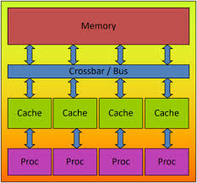

- Min Max Prgram

#include <iostream>
#include <vector>
#include <omp.h>
#include <climits>
using namespace std;
void min_reduction(vector<int>& arr) {
int min_value = INT_MAX;
#pragma omp parallel for reduction(min: min_value)
for (int i = 0; i < arr.size(); i++) {
if (arr[i] < min_value) {
min_value = arr[i];
}
}
cout << "Minimum value: " << min_value << endl;
}
void max_reduction(vector<int>& arr) {
int max_value = INT_MIN;
#pragma omp parallel for reduction(max: max_value)
for (int i = 0; i < arr.size(); i++) {
if (arr[i] > max_value) {
max_value = arr[i];
}
}
cout << "Maximum value: " << max_value << endl;
}
void sum_reduction(vector<int>& arr) {

int sum = 0;
#pragma omp parallel for reduction(+: sum)
for (int i = 0; i < arr.size(); i++) {
sum += arr[i];
}
cout << "Sum: " << sum << endl;
}
void average_reduction(vector<int>& arr) {
int sum = 0;
#pragma omp parallel for reduction(+: sum)
for (int i = 0; i < arr.size(); i++) {
sum += arr[i];
}
cout << "Average: " << (double)sum / arr.size() << endl;
}
int main() {
vector<int> arr = {5, 2, 9, 1, 7, 6, 8, 3, 4};
min_reduction(arr);
max_reduction(arr);
sum_reduction(arr);
average_reduction(arr);
}

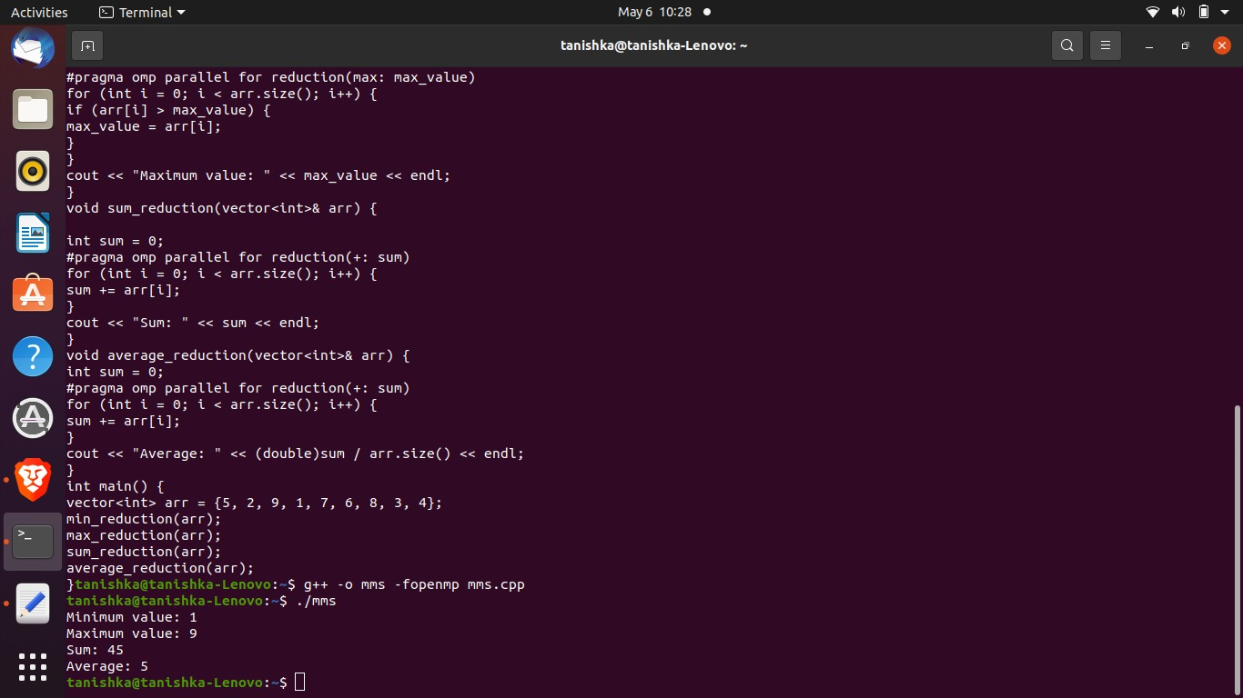

=============================================

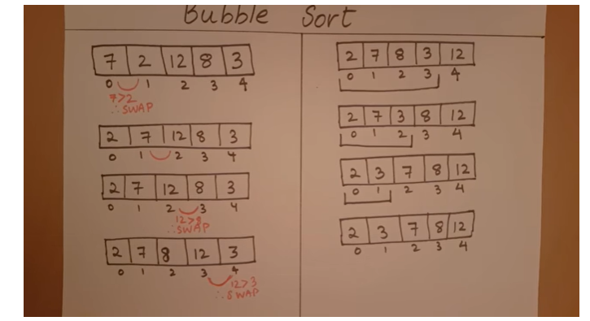

Bubble Sort Code-

#include <iostream>
#include <vector>
#include <omp.h>
using namespace std;
void bubble_sort_odd_even(vector<int>& arr) {
bool isSorted = false;
while (!isSorted) {
isSorted = true;
#pragma omp parallel for
for (int i = 0; i < arr.size() - 1; i += 2) {
if (arr[i] > arr[i + 1]) {
swap(arr[i], arr[i + 1]);
isSorted = false;
}
}
#pragma omp parallel for
for (int i = 1; i < arr.size() - 1; i += 2) {
if (arr[i] > arr[i + 1]) {
swap(arr[i], arr[i + 1]);
isSorted = false;
}
}
}
}

int main() {
vector<int> arr = {5, 2, 9, 1, 7, 6, 8, 3, 4};
double start, end;
// Measure performance of parallel bubble sort using odd-
//even transposition
start = omp_get_wtime();
bubble_sort_odd_even(arr);
end = omp_get_wtime();
cout << "Parallel bubble sort using odd-even transposition time: " << end - start << endl;
}
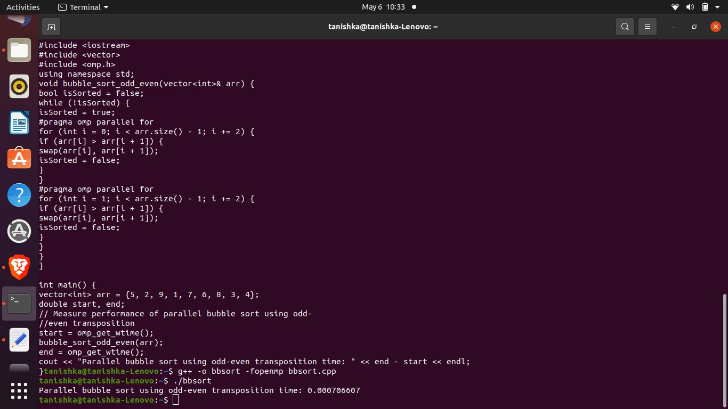

===================================================================

Merge Sort
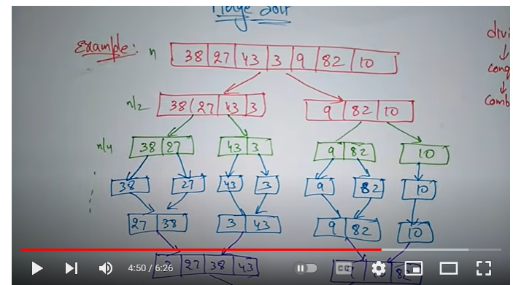
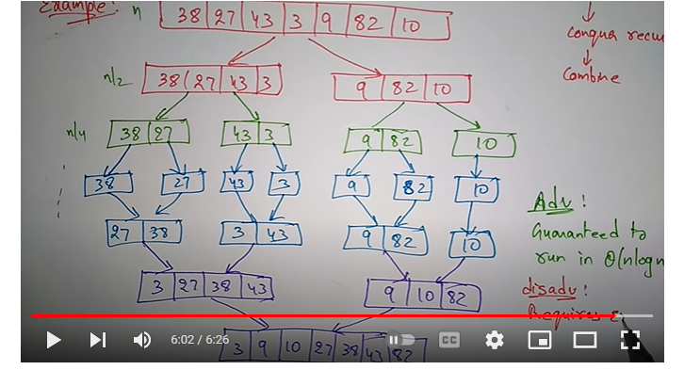

#include <iostream>
#include <vector>
#include <omp.h>
using namespace std;
void merge(vector<int>& arr, int l, int m, int r) {
int i, j, k;
int n1 = m - l + 1;
int n2 = r - m;
vector<int> L(n1), R(n2);
for (i = 0; i < n1; i++) {
L[i] = arr[l + i];
}
for (j = 0; j < n2; j++) {
R[j] = arr[m + 1 + j];
}
i = 0;
j = 0;
k = l;
while (i < n1 && j < n2) {
if (L[i] <= R[j]) {
arr[k++] = L[i++];
} else {
arr[k++] = R[j++];
}
}
}
void merge_sort(vector<int>& arr, int l, int r) {
if (l < r) {
int m = l + (r - l) / 2;
#pragma omp task
merge_sort(arr, l, m);
#pragma omp task
merge_sort(arr, m + 1, r);
merge(arr, l, m, r);
}
}
void parallel_merge_sort(vector<int>& arr) {
#pragma omp parallel
{
#pragma omp single
merge_sort(arr, 0, arr.size() - 1);
}
}
int main() {
vector<int> arr = {5, 2, 9, 1, 7, 6, 8, 3, 4};
double start, end;
// Measure performance of sequential merge sort
start = omp_get_wtime();
merge_sort(arr, 0, arr.size() - 1);
end = omp_get_wtime();
cout << "Sequential merge sort time: " << end - start <<endl;
// Measure performance of parallel merge sort
arr = {5, 2, 9, 1, 7, 6, 8, 3, 4};
start = omp_get_wtime();
parallel_merge_sort(arr);
end = omp_get_wtime();
return 0;
}

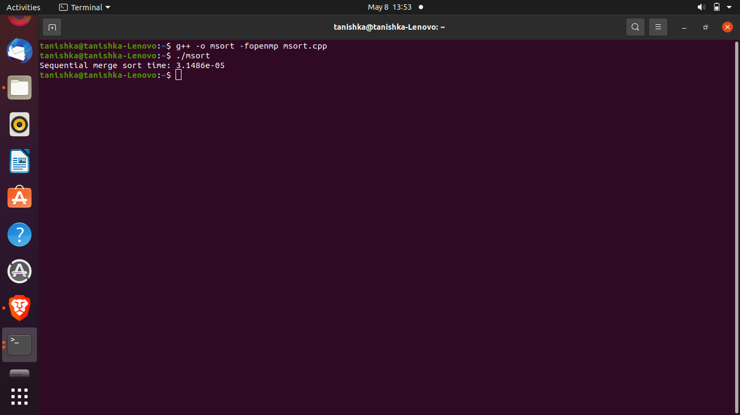
=====================================================================================

DFS Concept -
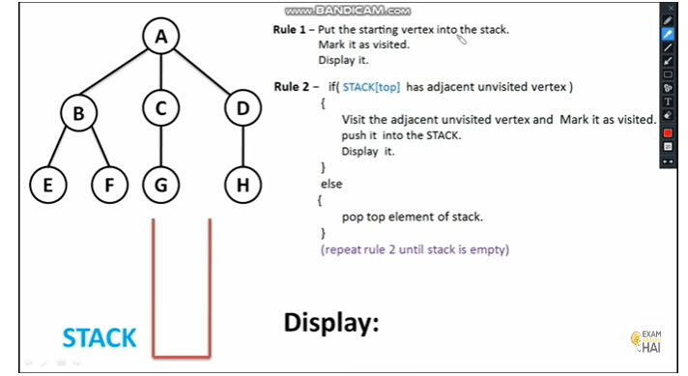

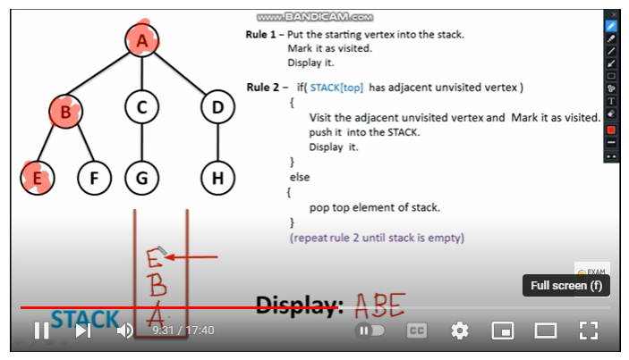
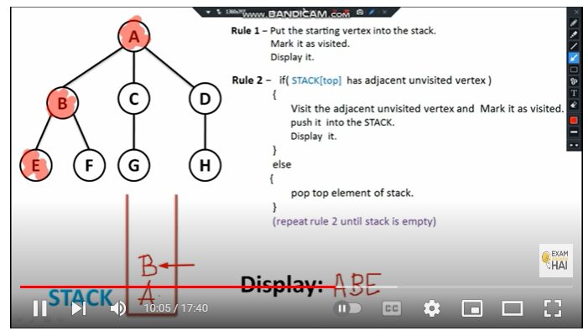
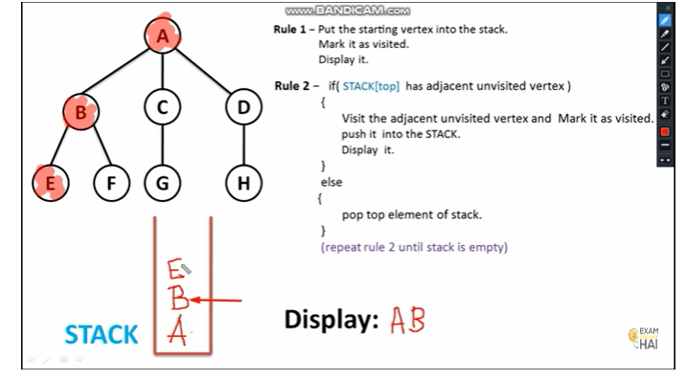
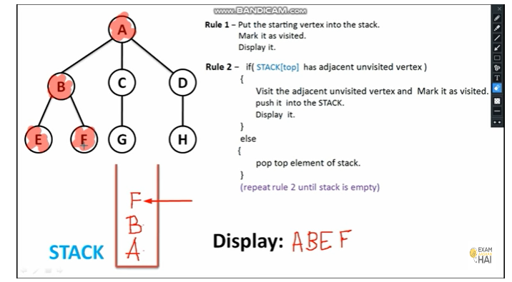
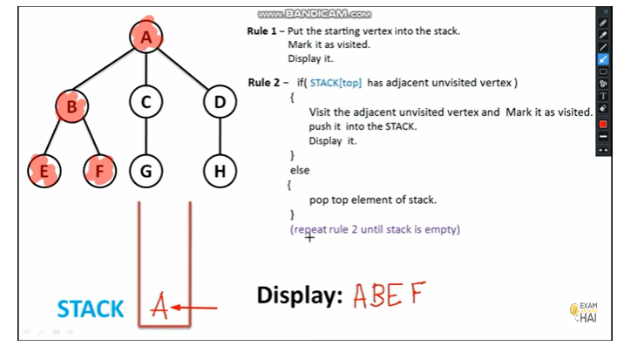
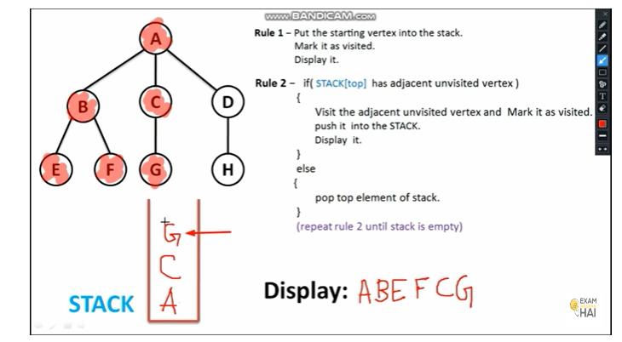

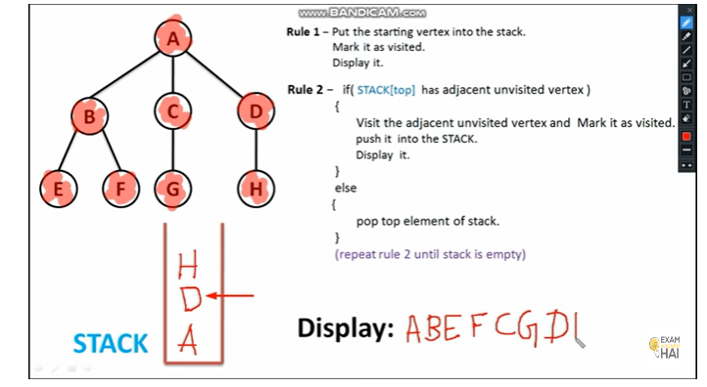
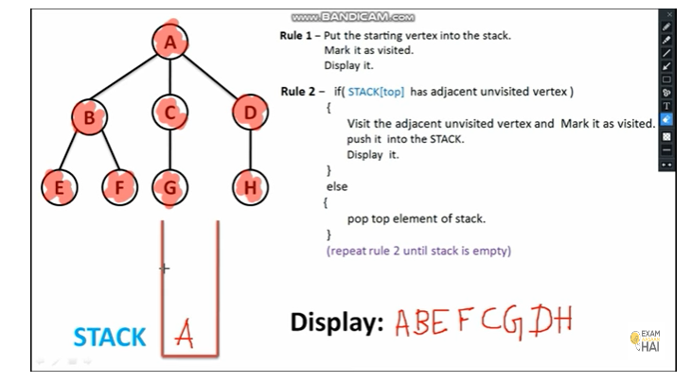
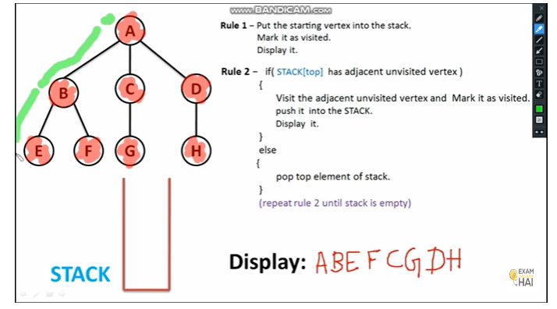
DFS Code-
#include <iostream>
#include <vector>
#include <omp.h>
using namespace std;
const int MAXN = 1e5;
vector<int> adj[MAXN+5]; // adjacency list
bool visited[MAXN+5]; // mark visited nodes
void dfs(int node) {
visited[node] = true;
#pragma omp parallel for
for (int i = 0; i < adj[node].size(); i++) {
int next_node = adj[node][i];
if (!visited[next_node]) {
dfs(next_node);
}
}
}
int main() {
cout << "Please enter nodes and edges";
int n, m; // number of nodes and edges
cin >> n >> m;

for (int i = 1; i <= m; i++) {
int u, v; // edge between u and v
cin >> u >> v;
adj[u].push_back(v);
adj[v].push_back(u);
}

int start_node; // start node of DFS
cin >> start_node;

dfs(start_node);

// Print visited nodes
for (int i = 1; i <= n; i++) {
if (visited[i]) {
cout << i << " ";
}
}
cout << endl;

return 0;
}

======================================================

BFS Concept:
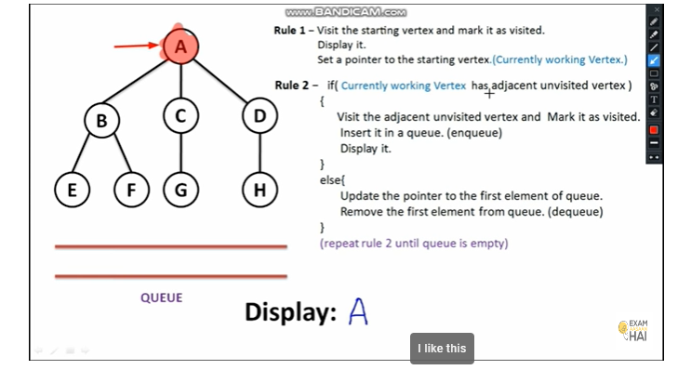

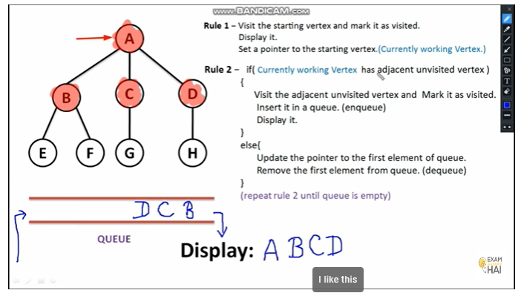

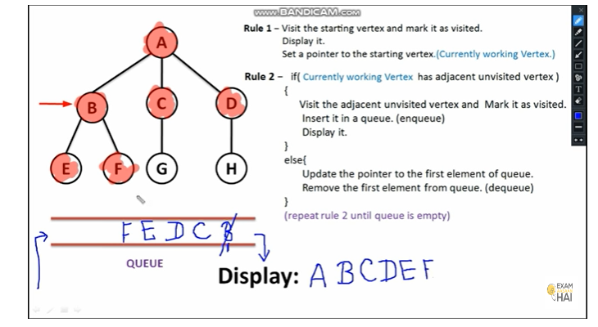

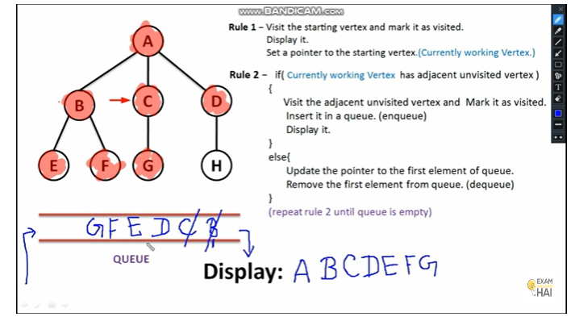
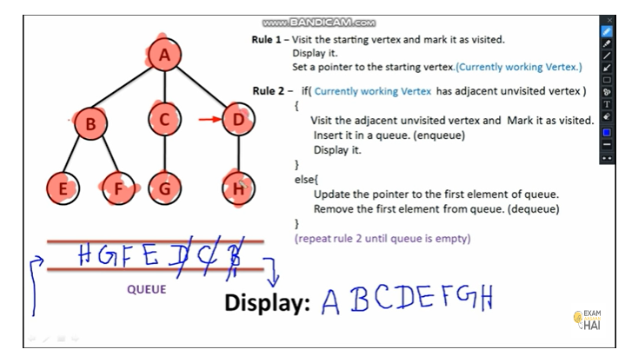

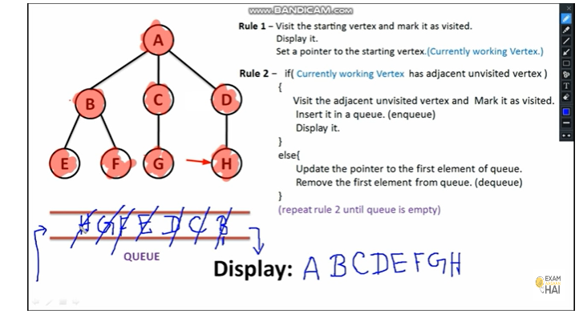
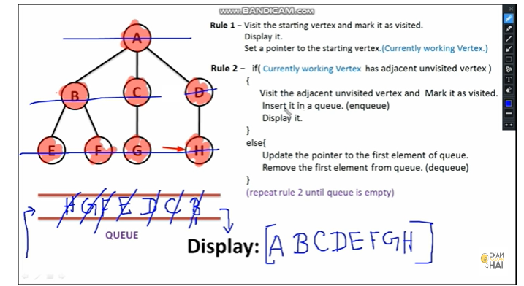

BFS Code-
#include <iostream>
#include <queue>
#include <vector>
#include <omp.h>

using namespace std;

int main() {
int num_vertices, num_edges, source;
cin >> num_vertices >> num_edges >> source;

vector<vector<int>> adj_list(num_vertices + 1);
for (int i = 0; i < num_edges; i++) {
int u, v;
cin >> u >> v;
adj_list[u].push_back(v);
adj_list[v].push_back(u);
}

queue<int> q;
vector<bool> visited(num_vertices + 1, false);

q.push(source);
visited[source] = true;

while (!q.empty()) {
int curr_vertex = q.front();
q.pop();

cout << curr_vertex << " ";

#pragma omp parallel for shared(adj_list, visited, q) schedule(dynamic)
for (int i = 0; i < adj_list[curr_vertex].size(); i++) {
int neighbour = adj_list[curr_vertex][i];
if (!visited[neighbour]) {
visited[neighbour] = true;
q.push(neighbour);
}
}
}

return 0;
}

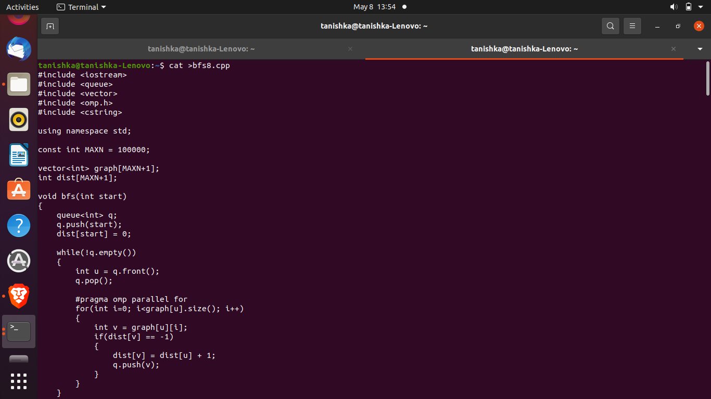

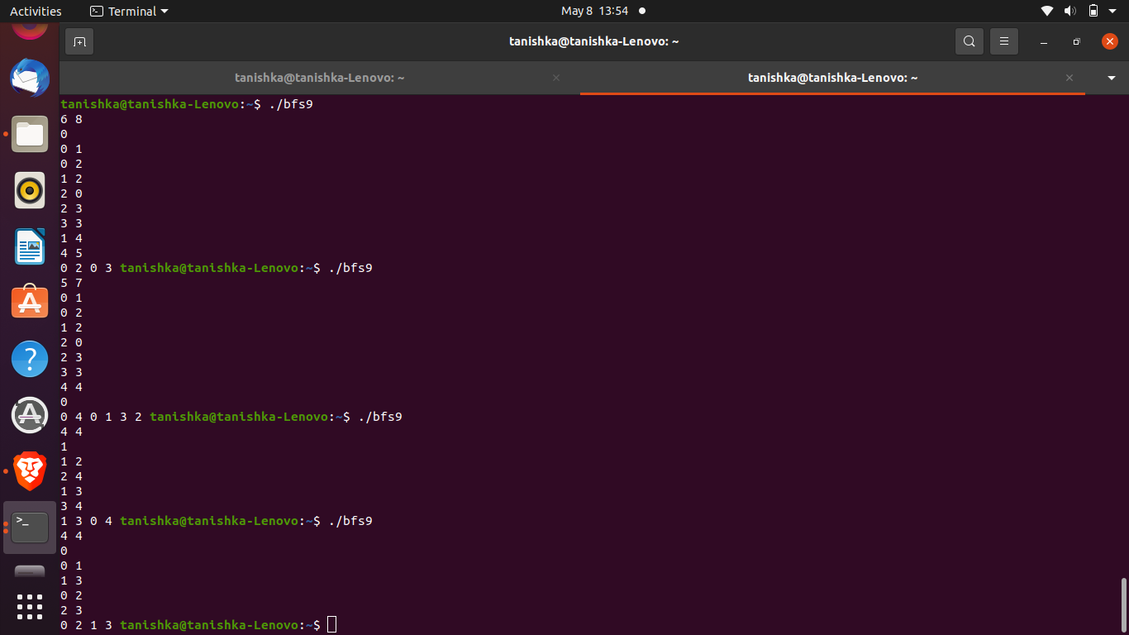

Vector Addition Program
!nvcc --version

!pip install git+https://github.com/afnan47/cuda.git
%load_ext nvcc_plugin

%%cu
#include <iostream>
using namespace std;
__global__
void add(int* A, int* B, int* C, int size) {
int tid = blockIdx.x * blockDim.x + threadIdx.x;
if (tid < size) {
C[tid] = A[tid] + B[tid];
}
}
void initialize(int* vector, int size) {
for (int i = 0; i < size; i++) {
vector[i] = rand() % 10;
}
}
void print(int* vector, int size) {
for (int i = 0; i < size; i++) {
cout << vector[i] << " ";
}
cout << endl;
}
int main() {
int N = 4;
int* A, * B, * C;
int vectorSize = N;
size_t vectorBytes = vectorSize * sizeof(int);
A = new int[vectorSize];
B = new int[vectorSize];
C = new int[vectorSize];
initialize(A, vectorSize);
initialize(B, vectorSize);
cout << "Vector A: ";
print(A, N);
cout << "Vector B: ";
print(B, N);
int* X, * Y, * Z;
cudaMalloc(&X, vectorBytes);
cudaMalloc(&Y, vectorBytes);
cudaMalloc(&Z, vectorBytes);
cudaMemcpy(X, A, vectorBytes, cudaMemcpyHostToDevice);
cudaMemcpy(Y, B, vectorBytes, cudaMemcpyHostToDevice);
int threadsPerBlock = 256;
int blocksPerGrid = (N + threadsPerBlock - 1) / threadsPerBlock;
add<<<blocksPerGrid, threadsPerBlock>>>(X, Y, Z, N);
cudaMemcpy(C, Z, vectorBytes, cudaMemcpyDeviceToHost);
cout << "Addition: ";
print(C, N);
delete[] A;
delete[] B;
delete[] C;
cudaFree(X);
cudaFree(Y);
cudaFree(Z);
return 0;
}

Output:
Vector A: 3 6 7 5
Vector B: 3 5 6 2
Addition: 6 11 13 7

Matrix multiplication
!nvcc --version

!pip install git+https://github.com/afnan47/cuda.git
%load_ext nvcc_plugin

%%cu
#include <iostream>
#include <cuda.h>

using namespace std;

#define BLOCK_SIZE 2

__global__ void gpuMM(float *A, float *B, float *C, int N)
{
// Matrix multiplication for NxN matrices C=A*B
// Each thread computes a single element of C
int row = blockIdx.y*blockDim.y + threadIdx.y;
int col = blockIdx.x*blockDim.x + threadIdx.x;

float sum = 0.f;
for (int n = 0; n < N; ++n)
sum += A[row*N+n]*B[n*N+col];

C[row*N+col] = sum;
}

int main(int argc, char *argv[])
{int N;float K;
// Perform matrix multiplication C = A*B
// where A, B and C are NxN matrices
// Restricted to matrices where N = K*BLOCK_SIZE;
cout<<"Enter a Value for Size/2 of matrix";
cin>>K;

K = 1;
N = K*BLOCK_SIZE;

cout << "\n Executing Matrix Multiplcation" << endl;
cout << "\n Matrix size: " << N << "x" << N << endl;

// Allocate memory on the host
float *hA,*hB,*hC;
hA = new float[N*N];
hB = new float[N*N];
hC = new float[N*N];

// Initialize matrices on the host
for (int j=0; j<N; j++){
for (int i=0; i<N; i++){
hA[j*N+i] = 2;
hB[j*N+i] = 4;

}
}

// Allocate memory on the device
int size = N*N*sizeof(float); // Size of the memory in bytes
float *dA,*dB,*dC;
cudaMalloc(&dA,size);
cudaMalloc(&dB,size);
cudaMalloc(&dC,size);

dim3 threadBlock(BLOCK_SIZE,BLOCK_SIZE);
dim3 grid(K,K);
cout<<"\n Input Matrix 1 \n";
for (int row=0; row<N; row++){
for (int col=0; col<N; col++){

cout<<hA[row*col]<<" ";

}
cout<<endl;
}
cout<<"\n Input Matrix 2 \n";
for (int row=0; row<N; row++){
for (int col=0; col<N; col++){

cout<<hB[row*col]<<" ";

}
cout<<endl;
}
// Copy matrices from the host to device
cudaMemcpy(dA,hA,size,cudaMemcpyHostToDevice);
cudaMemcpy(dB,hB,size,cudaMemcpyHostToDevice);

//Execute the matrix multiplication kernel

gpuMM<<<grid,threadBlock>>>(dA,dB,dC,N);

// Now do the matrix multiplication on the CPU
/*float sum;
for (int row=0; row<N; row++){
for (int col=0; col<N; col++){
sum = 0.f;
for (int n=0; n<N; n++){
sum += hA[row*N+n]*hB[n*N+col];
}
hC[row*N+col] = sum;
cout << sum <<" ";

}
cout<<endl;
}*/

// Allocate memory to store the GPU answer on the host
float *C;
C = new float[N*N];

// Now copy the GPU result back to CPU
cudaMemcpy(C,dC,size,cudaMemcpyDeviceToHost);

// Check the result and make sure it is correct
cout <<"\n\n\n\n\n Resultant matrix\n\n";
for (int row=0; row<N; row++){
for (int col=0; col<N; col++){

cout<<C[row*col]<<" ";

}
cout<<endl;
}

cout << "Finished." << endl;
}

Output-
Matrix size: 2x2

Input Matrix 1
2 2
2 2

Input Matrix 2
4 4
4 4

Resultant matrix

16 16
16 16
Finished.

